1. INTRODUCTION
1.1. Project Overview
Flavour Fusion is an AI-driven recipe blogging web application designed to generate customized and well-structured recipe blogs based on user input. The application allows users to enter a recipe topic and specify the desired word count. Using a pre-trained generative AI model, the system produces detailed and engaging recipe content in a short time.
The project aims to simplify the process of recipe content creation for food bloggers, cooking enthusiasts, and busy individuals. Instead of manually writing lengthy recipes, users can rely on the application to generate high-quality content instantly. The application is built using Streamlit for the user interface and integrates the Gemini Flash Lite (models/gemini-flash-lite-latest) model for efficient and fast text generation.
Overall, Flavour Fusion demonstrates the practical use of generative AI in content creation by providing a user-friendly, time-saving, and effective solution for automated recipe blog generation.
1.2. Objectives
The main objectives of the Flavour Fusion: AI-Driven Recipe Blogging project are:
- To develop a web-based application that generates recipe blogs using artificial intelligence
- To allow users to create customized recipe content by providing a topic and word count
- To reduce the time and effort required for manual recipe writing
- To integrate a pre-trained generative AI model for fast and accurate text generation
- To provide a simple and user-friendly interface using Streamlit
- To enhance user experience through efficient and engaging content generation

2. Ideation Phase
2.1. Problem Statement
Therefore, food bloggers and busy individuals are in dire need of an easier way to pen or write a detailed recipe blog in the shortest length of time. Writing recipes manually requires a lot of efforts, creativities, and proper formatting that are really very time-consuming. Also, most of the recipes available online tend to be general and do not meet specific user needs. The result is usually frustration and reduced productivity. The Flavour Fusion application solves this problem by using an AI model to quickly generate customized and well-structured recipe blogs based on user input.
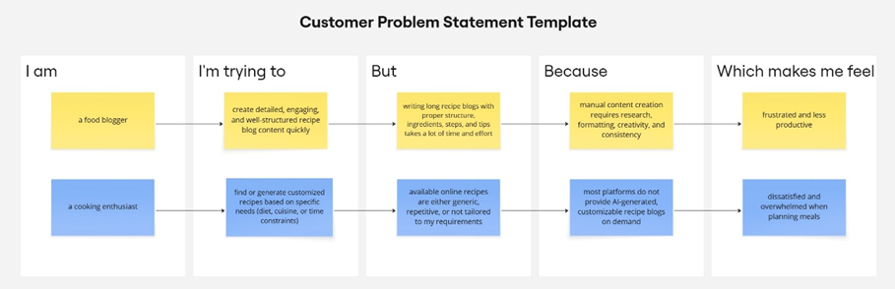
Problem  Statement  (PS) | I am | I’m trying to | But | Because | Which makes me feel
PS-1 | A food blogger | Create detailed, and high-quality recipe blog content in less time | Writing long and recipe blogs manually is time-consuming | It requires research, creativity, formatting, and consistency | Frustrated and less productive
PS-2 | A cooking enthusiast | Generate customized recipes | Existing recipes available online are generic and not customizable | Most platforms do not offer AI-driven recipe blog generation | Dissatisfied and overwhelmed while planning meals
2.2. Empathy Map Canvas
Empathy Map Canvas:
An empathy map is a simple, easy-to-digest visual that captures knowledge about a user’s behaviours and attitudes.

It is a useful tool to helps teams better understand their users.
Creating an effective solution requires understanding the true problem and the person who is experiencing it. The exercise of creating the map helps participants consider things from the user’s perspective along with his or her goals and challenges.
Example:
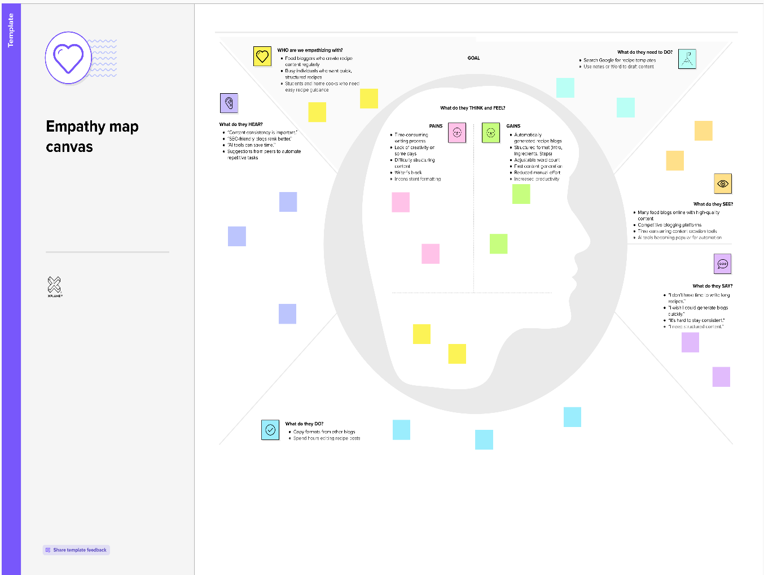

2.3 Brainstorming
Brainstorm & Idea Prioritization:
Brainstorming provides a free and open environment that encourages everyone within a team to participate in the creative thinking process that leads to problem solving. Prioritizing volume over value, out-of-the-box ideas are welcome and built upon, and all participants are encouraged to collaborate, helping each other develop a rich amount of creative solutions.
Use this template in your own brainstorming sessions so your team can unleash their imagination and start shaping concepts even if you're not sitting in the same room.

Step-1: Team Gathering, Collaboration and Select the Problem Statement
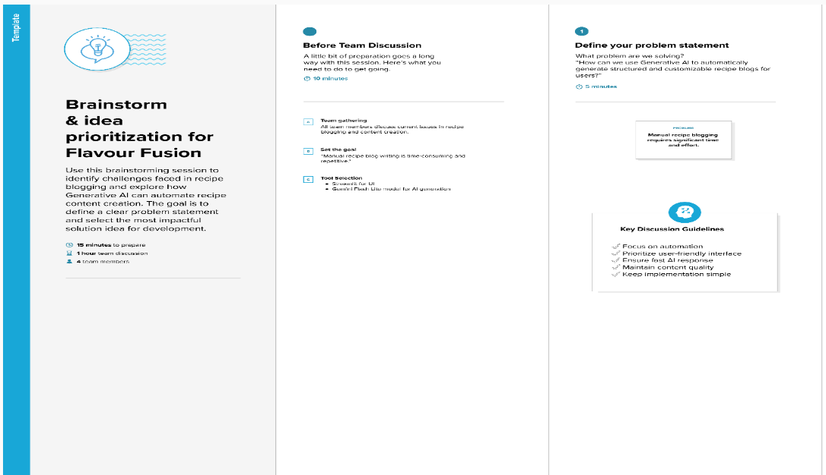

Step-2: Brainstorm, Idea Listing and Grouping
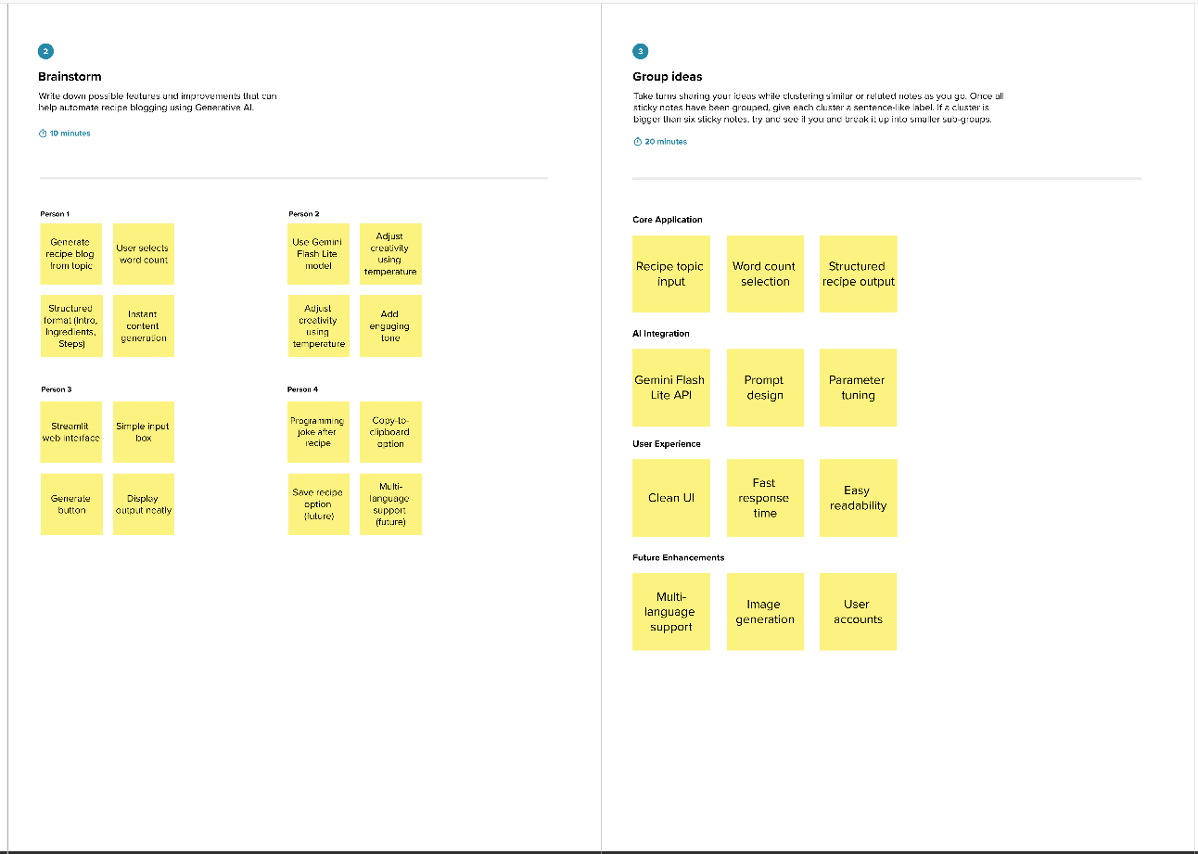

Step-3: Idea Prioritization
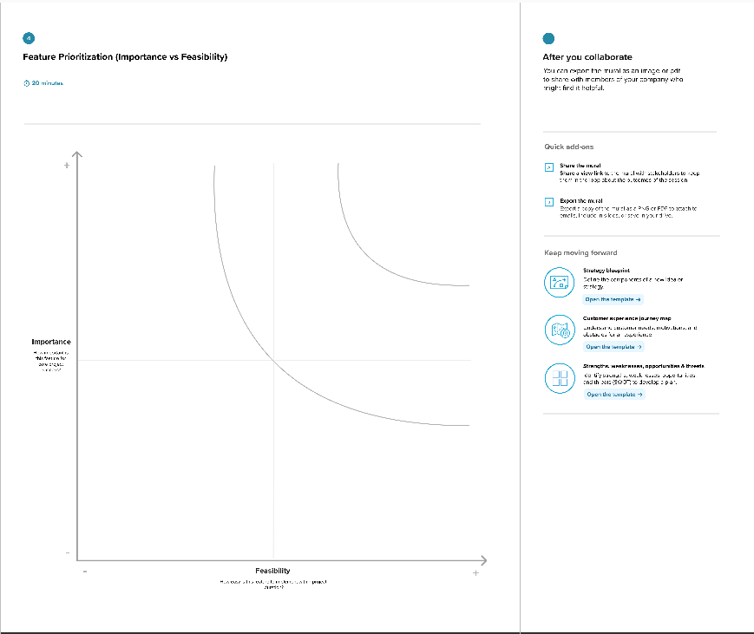

3. Requirement Analysis
3.1. Solution Requirement
Functional Requirements:
Following are the functional requirements of the proposed solution.
FR No. | Functional Requirement (Epic) | Sub Requirement (Story / Sub-Task)
FR-1 | Recipe Input Module | Enter recipe topic & Select word count
FR-2 | Input Validation | Validate empty input & word count range
FR-3 | AI Integration | Connect to Gemini Flash Lite API  Send structured prompt to model
FR-4 | Recipe Generation | Generate structured recipe blog  Include introduction, ingredients, steps
FR-5 | Output Display | Display generated recipe in UI  Allow user to copy content
FR-6 | Additional Feature | Generate programming joke (optional feature)

Non-functional Requirements:
Following are the non-functional requirements of the proposed solution.
FR No. | Non-Functional Requirement | Description
NFR-1 | Usability | The application must have a simple and intuitive Streamlit interface that is easy to use.
NFR-2 | Security | API keys must be securely stored and not exposed in the frontend.
NFR-3 | Reliability | The system should generate consistent and structured outputs for valid inputs.
NFR-4 | Performance | Recipe generation should complete within a few seconds.
NFR-5 | Availability | The application should be accessible online whenever deployed.
NFR-6 | Scalability | The system should handle multiple users without significant performance degradation.
3.2. Data Flow Diagram
Data Flow Diagrams:
A Data Flow Diagram (DFD) is a traditional visual representation of the information flows within a system. A neat and clear DFD can depict the right amount of the system requirement graphically. It shows how data enters and leaves the system, what changes the information, and where data is stored.
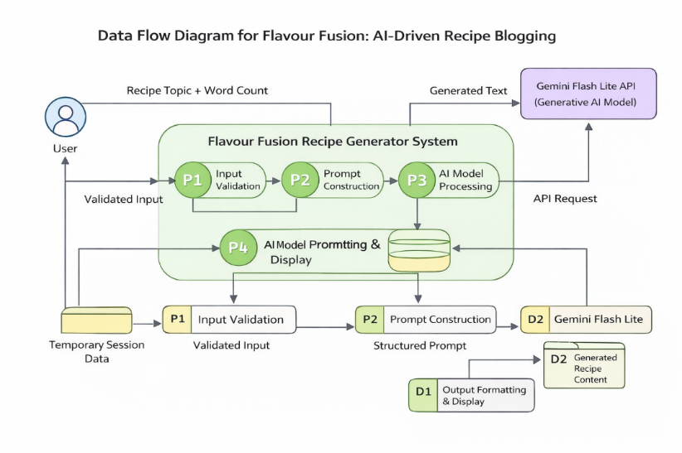
User Stories
Use the below template to list all the user stories for the product.
User Type | Functional Requirement (Epic) | User Story Number | User Story / Task | Acceptance criteria | Priority | Release
Customer (Mobile user) | User Interface Setup | USN-1 | As a user, I can access a Streamlit-based interface to enter a recipe topic and word count. | I can access my account / dashboard | High | Sprint-1
Administrator | Input Validation | USN-2 | As a user, I want the application to validate my inputs before generating the recipe. | I can validate the inputs | High | Sprint-1
Customer Care Executive | AI Model Integration | USN-3 | As a user, I want the system to generate a recipe blog using the Gemini Flash Lite model. | I can integrate model | High | Sprint-2
Administrator | Joke Generation | USN-4 | As a user, I want to see a programming joke while the recipe is being generated. | I can generate a joke for user interaction while recipe generation delayed | Medium | Sprint-2
Customer (Mobile user) | Output Display | USN-5 | As a user, I want to view the generated recipe blog clearly on the screen. | I can see the output of recipe generated | High | Sprint-3
Customer Care Executive | Deployment | USN-6 | As a user, I want the application to be deployed and accessible through the internet. | I can deploy in the system | Medium | Sprint-3

3.3. Technology Stack
Technical Architecture:
The Deliverable shall include the architectural diagram as below and the information as per the table1 & table 2
Table-1 : Components & Technologies:
S.No | Component | Description | Technology
 | User Interface | Web-based interface where users enter recipe topic and word count. | Streamlit (Python Web Framework)
 | Application Logic-1 | Input validation and prompt construction logic | Python
 | Application Logic-2 | AI request handling and response processing | Google Generative AI API
 | Application Logic-3 | Recipe formatting and output structuring | Python
 | File Storage | Local environment for source code and logs | Local File System
 | External API-1 | Generative AI service for recipe blog generation | Gemini Flash Lite (models/gemini-flash-lite-latest)
 | Machine Learning Model | Pre-trained generative AI model for text generation | Gemini Flash Lite Model
 | Infrastructure (Server / Cloud) | Deployment of application | Streamlit Cloud / Local Deployment

Table-2: Application Characteristics:
S.No | Characteristics | Description | Technology
 | Open-Source Frameworks | Web framework and development tools used | Streamlit, Python
 | Security Implementations | Secure storage of API keys and environment variables | Environment Variables (.env), Streamlit Secrets
 | Scalable Architecture | Web-based architecture supporting multiple users | Cloud-based deployment (Streamlit Cloud)
 | Availability | Application accessible online after deployment | Streamlit Cloud Hosting
 | Performance | Fast response generation using lightweight AI model | Gemini Flash Lite (optimized for low latency)

4. PROJECT DESIGN
4.1. Problem Solution Fit
Problem – Solution Fit Template:
The Problem-Solution Fit simply means that you have found a problem with your customer and that the solution you have realized for it actually solves the customer’s problem. It helps entrepreneurs, marketers and corporate innovators identify behavioral patterns and recognize what would work and why
Purpose:
- Solve complex problems in a way that fits the state of your customers.
- Succeed faster and increase your solution adoption by tapping into existing mediums and channels of behavior.
- Sharpen your communication and marketing strategy with the right triggers and messaging.
- Increase touch-points with your company by finding the right problem-behavior fit and building trust by solving frequent annoyances, or urgent or costly problems.
- Understand the existing situation in order to improve it for your target group.

Template:

4.2. Proposed Solution
Proposed Solution Template:
Project team shall fill the following information in the proposed solution template.
S.No. | Parameter | Description
 | Problem Statement (Problem to be solved) | Many food bloggers, students, and busy individuals struggle to create well-structured and detailed recipe blogs due to time constraints and lack of consistent creativity. Manual recipe writing is repetitive, time-consuming, and requires formatting effort. There is a need for an automated system that can generate structured recipe blogs quickly and efficiently.
 | Idea / Solution description | Flavour Fusion is an AI-powered web application that generates customized recipe blogs based on user input. Users enter a recipe topic and desired word count, and the system uses a pre-trained generative AI model (Gemini Flash Lite) to create a complete, structured recipe blog including introduction, ingredients, and preparation steps. The application provides instant results through a simple Streamlit-based interface.
 | Novelty / Uniqueness | Unlike traditional recipe platforms that only display pre-written recipes, Flavour Fusion dynamically generates unique, customized recipe blogs in real-time. The integration of Generative AI allows users to control word count and receive structured content instantly, making it more flexible and interactive than static recipe websites.
 | Social Impact / Customer Satisfaction | The solution saves time for food bloggers, home cooks, and students by automating content creation. It improves productivity, reduces manual effort, and provides accessible recipe content generation. Users benefit from structured and ready-to-use blogs without requiring advanced writing skills.
 | Business Model (Revenue Model) | The application can adopt a freemium model where basic recipe generation is free, and advanced features (multi-language support, image generation, premium templates) are offered through subscription. Revenue can also be generated through advertisements, affiliate marketing, or API-based enterprise usage.
 | Scalability of the Solution | The application is cloud-deployable and uses a scalable generative AI API. It can handle multiple users simultaneously when deployed on cloud infrastructure. Additional features such as multi-language support, user accounts, and content storage can be added to scale the system further.

4.3 Solution Architecture
Solution Architecture:
The solution architecture of Flavour Fusion consists of a Streamlit-based web application that collects user inputs and validates them. The application constructs a structured prompt and sends it to the Gemini Flash Lite generative AI model through an API call. The AI model generates a structured recipe blog, which is then formatted and displayed to the user. The system can be deployed locally or on a cloud platform such as Streamlit Cloud.
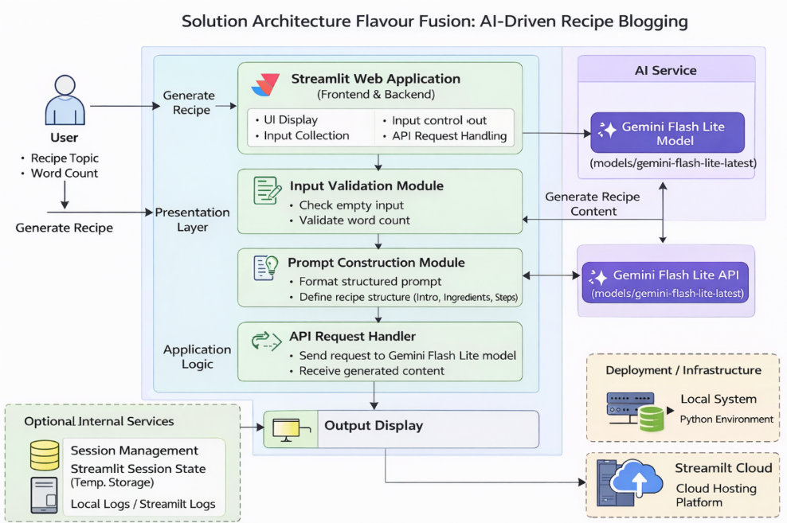

5. PROJECT PLANNING & SCHEDULING
5.1. Project Planning
Product Backlog, Sprint Schedule, and Estimation (4 Marks)
Use the below template to create product backlog and sprint schedule
Sprint | Functional Requirement (Epic) | User Story Number | User Story / Task | Story Points | Priority | Team Members
Sprint-1 | User Interface Setup | USN-1 | As a user, I can access a Streamlit-based interface to enter a recipe topic and word count. | 2 | High | All Team Members
Sprint-1 | Input Validation | USN-2 | As a user, I want the application to validate my inputs before generating the recipe. | 1 | High | All Team Members
Sprint-2 | AI Model Integration | USN-3 | As a user, I want the system to generate a recipe blog using the Gemini Flash Lite model. | 3 | High | All Team Members
Sprint-2 | Joke Generation | USN-4 | As a user, I want to see a programming joke while the recipe is being generated. | 1 | Medium | All Team Members
Sprint-3 | Output Display | USN-5 | As a user, I want to view the generated recipe blog clearly on the screen. | 2 | High | All Team Members
Sprint-3 | Deployment | USN-6 | As a user, I want the application to be deployed and accessible through the internet. | 2 | Medium | All Team Members

Project Tracker, Velocity & Burndown Chart: (4 Marks)
Sprint | Total Story Points | Duration | Sprint Start Date | Sprint End Date (Planned) | Story Points Completed (as on Planned End Date) | Sprint Release Date (Actual)
Sprint 1 | 20 | 4 Days | 28 January 2026 | 31 January 2026 | 20 | 31 January 2026
Sprint 1 | 20 | 4 Days | 28 January 2026 | 31 January 2026 | 20 | 31 January 2026
Sprint 2 | 20 | 8 Days | 02 February 2026 | 09 February 2026 | 20 | 09 February 2026
Sprint 2 | 20 | 8 Days | 02 February 2026 | 09 February 2026 | 20 | 09 February 2026
Sprint 3 | 20 | 7 Days | 12 February 2026 | 18 February 2026 | 20 | 18 February 2026
Sprint 3 | 20 | 7 Days | 12 February 2026 | 18 February 2026 | 20 | 18 February 2026

6. FUNCTIONAL AND PERFORMANCE TESTING
6.1 Performance Testing

Test Scenarios & Results
Test Case ID | Scenario (What to test) | Test Steps (How to test) | Expected Result | Actual Result | Pass/Fail
FT-01 | Recipe Topic Input Validation | Enter valid recipe topic and leave field empty | Valid input accepted, error shown for empty input | As Expected | Pass
FT-02 | Ingredient Input Validation | Enter valid ingredients and try empty/invalid inputs | Accepts valid input, shows warning for invalid input | As Expected | Pass
FT-03 | AI Recipe Generation | Enter recipe topic and click “Generate Recipe” | Structured recipe with title, ingredients, and steps generated | As Expected | Pass
FT-04 | Gemini API Connection Check | Trigger recipe generation with valid API key | API responds successfully and generates recipe | As Expected | Pass
FT-05 | Programming Joke Feature | Generate recipe and check joke display | Programming joke appears along with recipe | As Expected | Pass
PT-01 | Response Time Test | Measure time after clicking generate | Recipe generated within 3–5 seconds | Within Limit | Pass
PT-02 | Multiple Request Handling | Generate multiple recipes sequentially | Application handles requests without crash | Stable | Pass
PT-03 | Deployment Test | Access deployed app via browser | Application loads and works correctly online | Working | Pass

7. RESULTS
7.1. Output Screenshots
The complete execution of Flavour Fusion: AI-Driven Recipe Blogging application is represented step by step in the following screenshots.
Step 1: To run the Streamlit Application we have to use the command streamlit run app.py in the terminal in path where the app.py file is located.
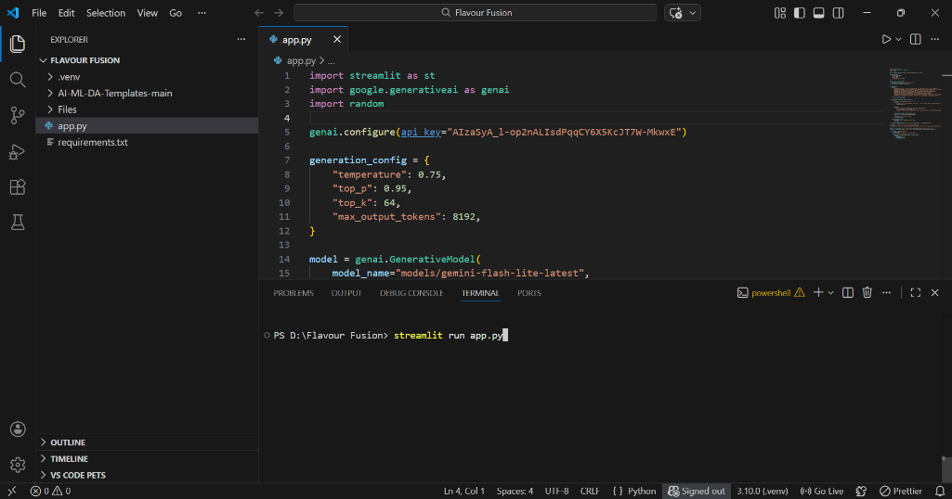
Step 2: After running the command in terminal, the code will get executed and the webpage will open directly. Another way to open webpage is that a localhost link will get generated in the terminal, we can access the webpage using that link.
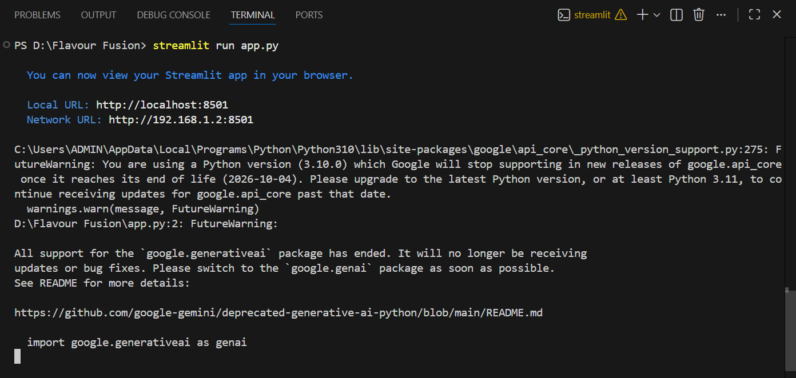
Step 3: The Streamlit webpage opens as shown in the figure given below. This is an automated webpage. No secondary HTML codes required to build this webpage. Python code itself consists the webpage building code.
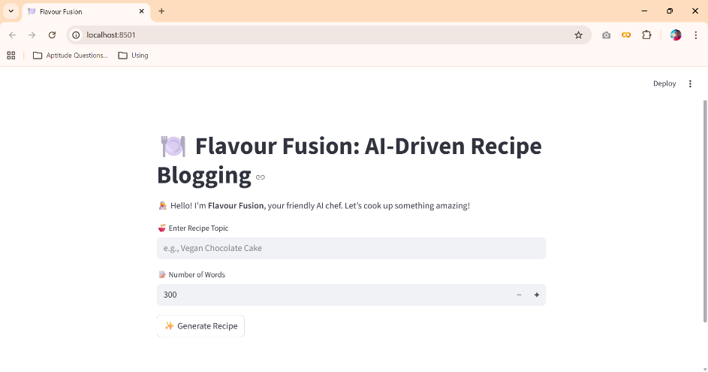
Step 3: The user has to give inputs in the website such as a Recipe Name and Number of Words. The Number of words means with how many words the recipe should be generated. After entering the required details, the user should click on Generate Recipe button to generate the recipe. Here I chose the Chocolate Cake Recipe with 400 words count.
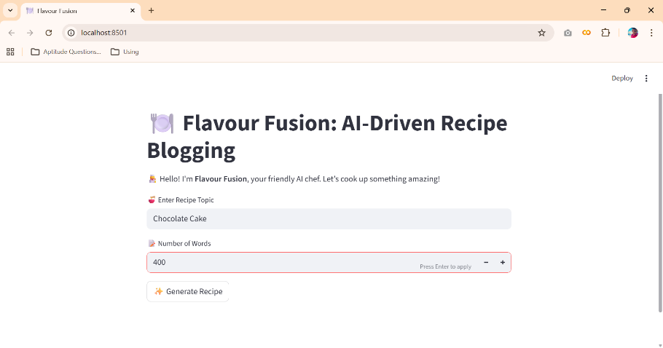
Step 4: After clicking the Generate Recipe button, in fraction of seconds a simple joke will be generated as shown in the below figure to engage the users if recipe generation get delayed. The Food Recipe will be generated based on the user inputs as shown in the following four images.
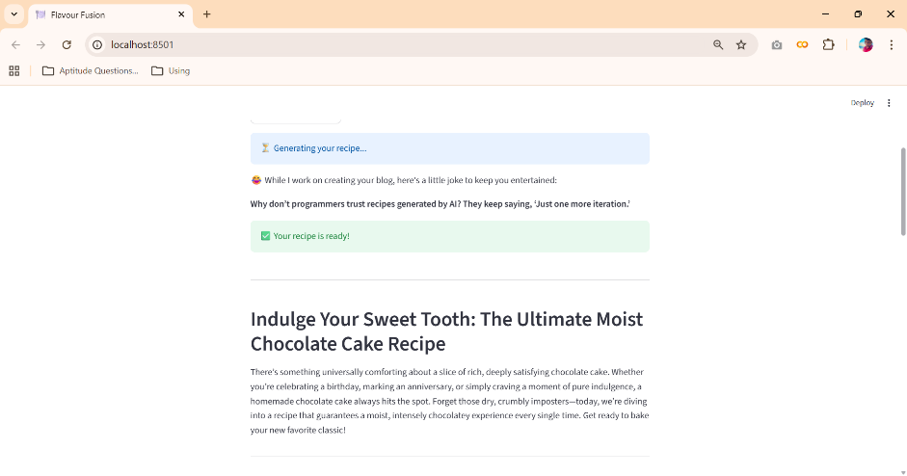
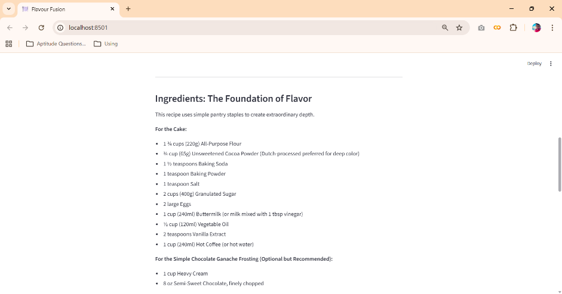
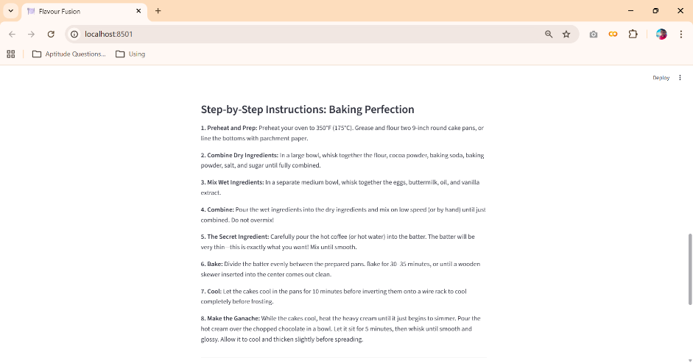
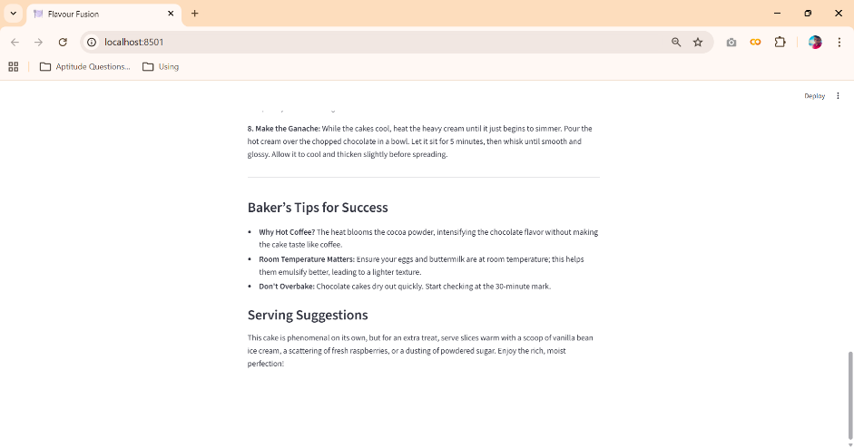

8. ADVANTAGES AND DISADVANTAGES
Advantages
- Saves time by automatically generating detailed recipe blogs
- Reduces manual effort for food bloggers and users
- Generates customized content based on user input
- User-friendly interface built using Streamlit
- Fast and efficient content generation using a pre-trained AI model
- No requirement for dataset collection or model training
Disadvantages
- Requires an active internet connection to access the AI model
- Depends on third-party AI APIs for content generation
- Limited to text-based recipe content only
- Output quality depends on the clarity of user input

9. CONCLUSION
The Flavour Fusion: AI-Driven Recipe Blogging project successfully demonstrates how generative AI can be used to automate recipe blog creation. The application allows users to generate customized and well-structured recipe content by providing a topic and word count, reducing the time and effort required for manual writing. By integrating a pre-trained AI model with a user-friendly Streamlit interface, the project delivers fast, efficient, and high-quality results, making it a useful tool for food bloggers and cooking enthusiasts.

10. FUTURE SCOPE
The Flavour Fusion project can be enhanced further by adding support for multiple languages to reach a wider audience. Future improvements may include generating recipe images along with text, adding user accounts to save favorite recipes, and providing personalized recipe recommendations. The application can also be extended to support voice-based input and mobile platform deployment, making it more accessible and user-friendly.

11. APPENDIX
11.1. Source Code
The source code for the Flavour Fusion: AI-Driven Recipe Blogging project includes the implementation of the Streamlit user interface, integration of the Gemini Flash Lite model using the Google Generative AI API, recipe blog generation logic, and the programmer joke feature. The code is written in Python and follows a modular and readable structure.
11.2. Github & Project Demo Link
Github Repository Link: https://github.com/Pradeep232823/Flavour_Fusion
Demo Link: https://drive.google.com/file/d/1G8qmgIvjposxqo5sTo6ar0ZR2qyFgdLL/view?usp=sharing

